**Task5-GPT**

**Applying Inline Styles with the Style Attribute**

Inline styles are CSS styles applied directly to individual HTML elements using the style attribute. This allows for quick customization of specific elements without needing to create or link to a separate stylesheet.

**Example HTML Document with Inline Styles**

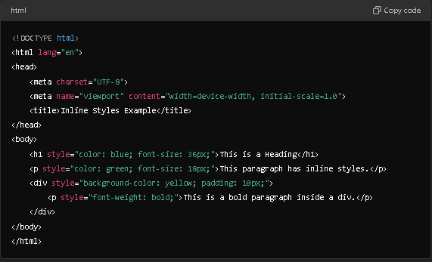

**Result:**

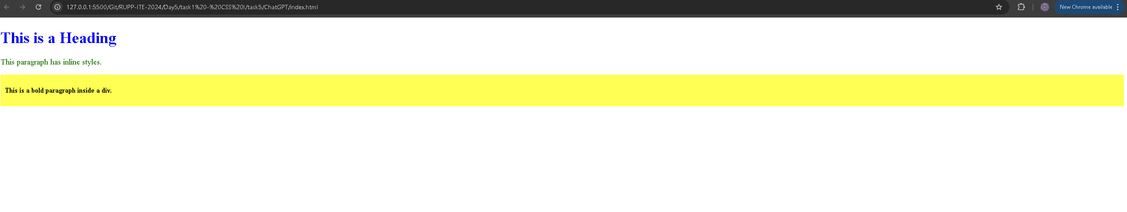

### Explanation of Inline Styles in the Example

* **<h1 style="color: blue; font-size: 36px;">**: This heading is styled with blue text and a font size of 36 pixels.
* **<p style="color: green; font-size: 18px;">**: This paragraph has green text and a font size of 18 pixels.
* **<div style="background-color: yellow; padding: 10px;">**: This div has a yellow background and padding of 10 pixels around its content.
* **<p style="font-weight: bold;">**: The nested paragraph within the div is styled to be bold.

### Pros and Cons of Using Inline Styles

#### Pros:

1. **Quick Implementation**: Inline styles allow for rapid application of specific styles without needing to create a separate stylesheet.
2. **High Specificity**: Inline styles override styles from external or internal stylesheets due to their high specificity.
3. **Ideal for Testing**: They are useful for testing changes quickly during development.

#### Cons:

1. **Poor Maintainability**: Inline styles can clutter HTML, making it less readable and harder to maintain, especially in larger projects.
2. **No Reusability**: Inline styles cannot be reused across multiple elements, leading to repetitive code.
3. **Mixing Content and Presentation**: They violate the principle of separating content (HTML) from presentation (CSS), making it difficult to manage styles collectively.
4. **Performance Issues**: Excessive use of inline styles can increase the size of HTML files, potentially impacting loading times.

### Conclusion

While inline styles can be convenient for quick changes, they are generally not recommended for larger or production-level projects. Using external stylesheets or internal CSS is often preferable for better maintainability, reusability, and adherence to best practices in web development.